EXPERIMENT – 12 FOREIGN TRADING SYSTEM

USECASE DIGRAM :-CC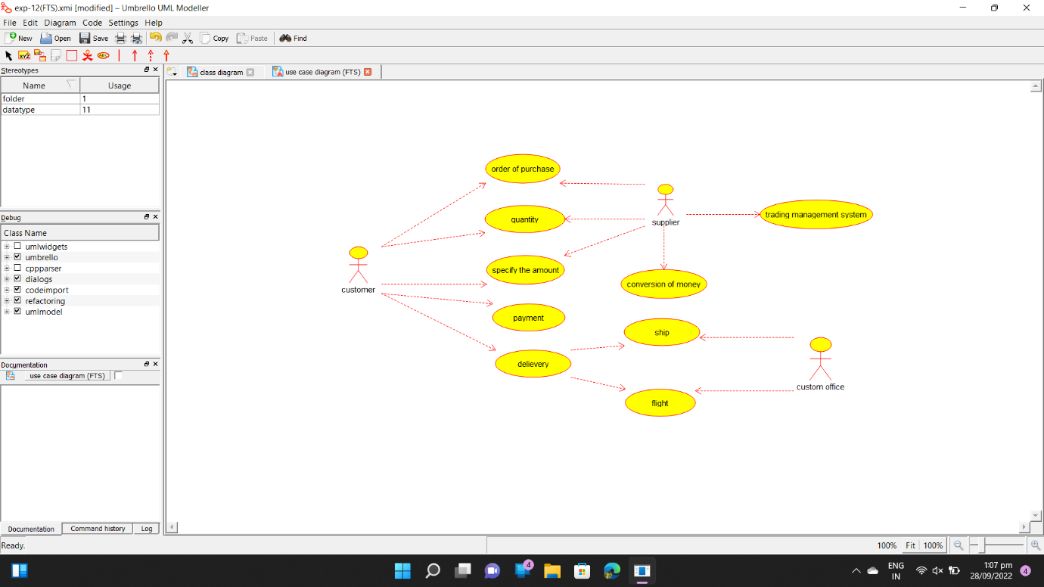

CLASS DIAGRAM :-

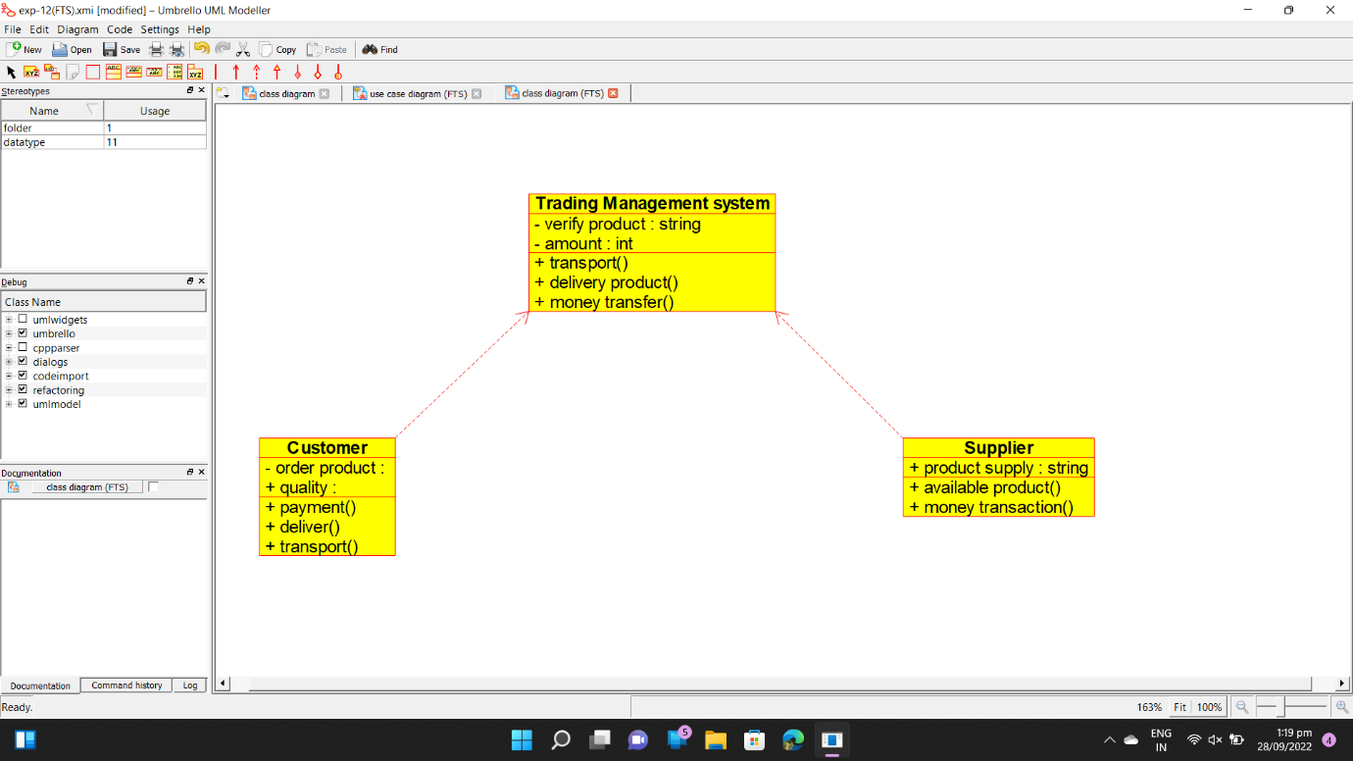

ACTIVITY DIAGRAM :- 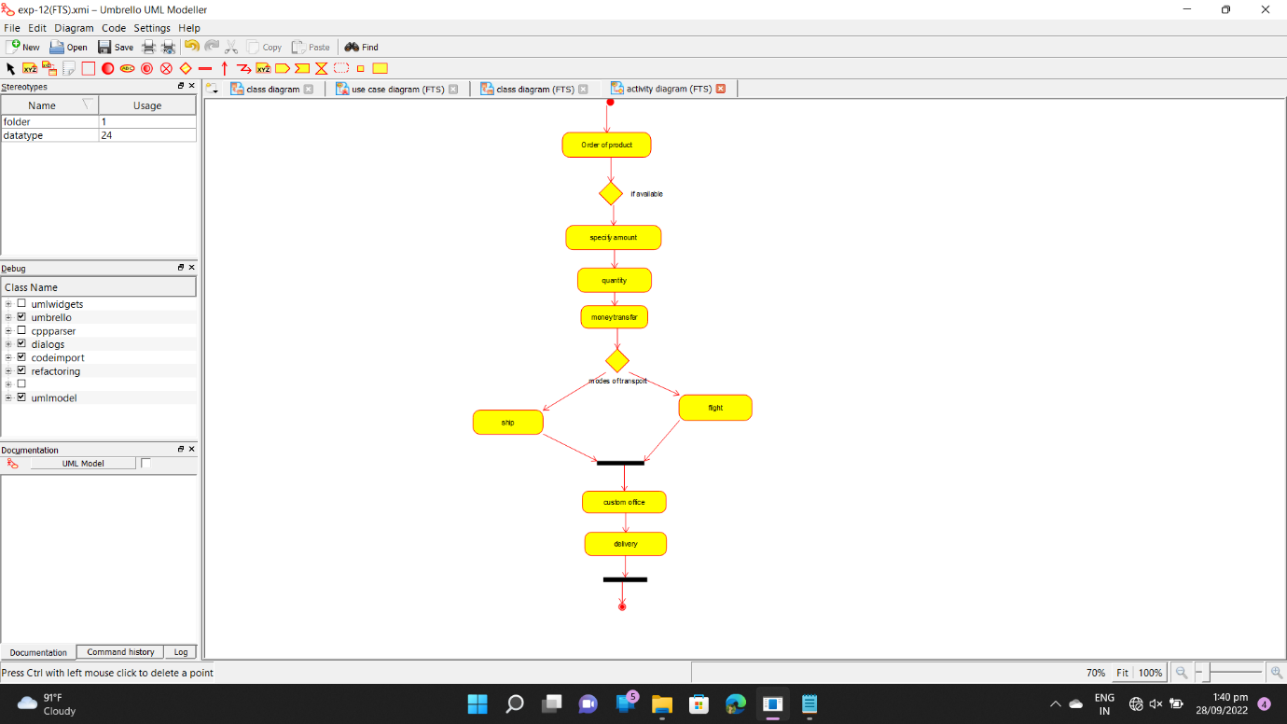

SEQUENCE DIAGRAM :- 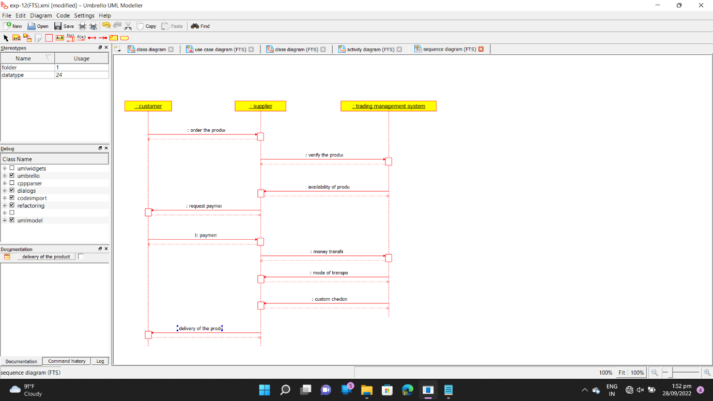

COLLABORATION DIAGRAM :- 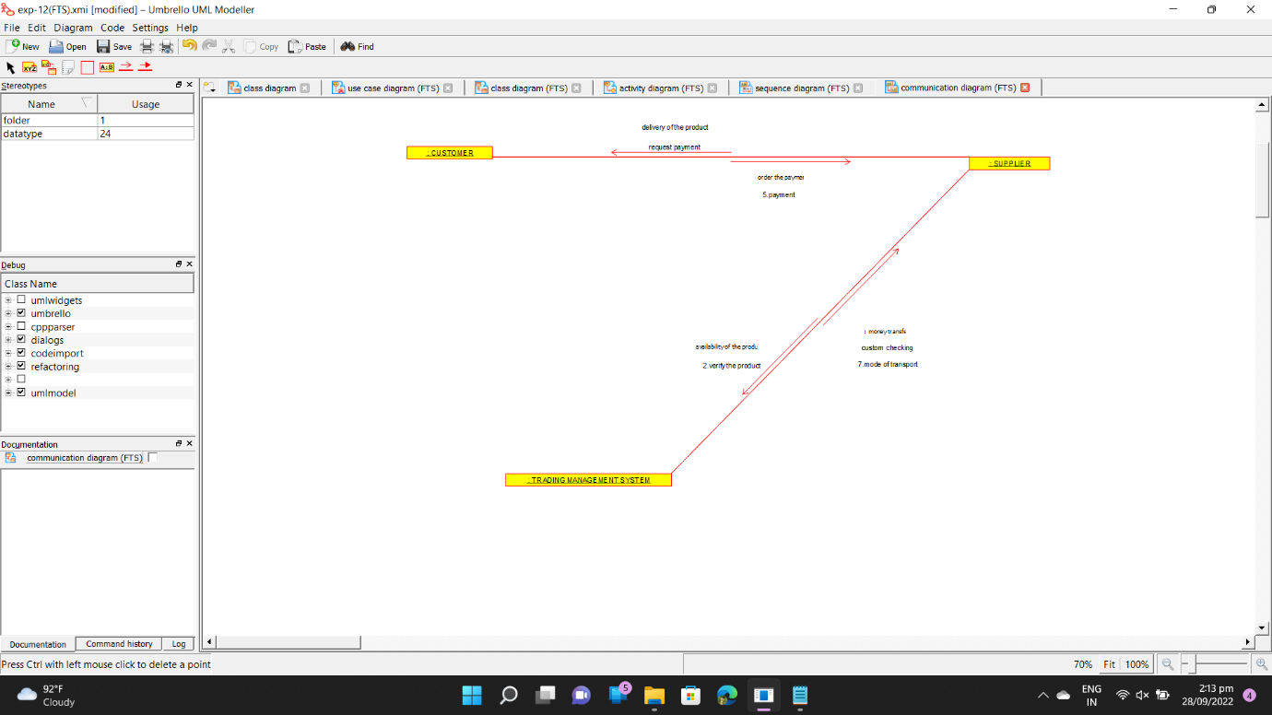

STATECHART DIAGRAM :-

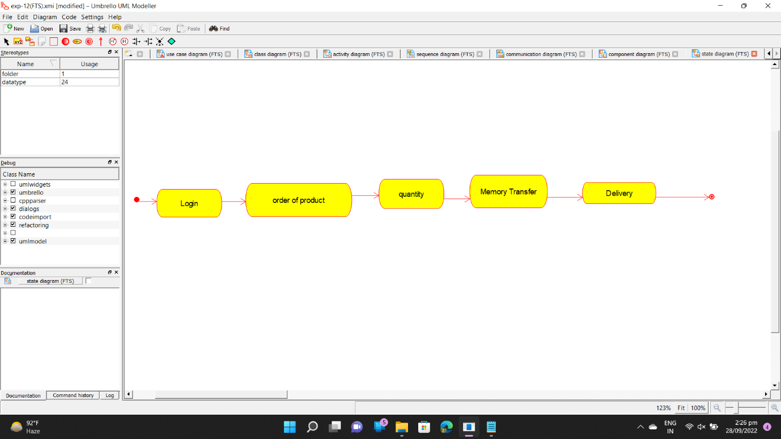

COMPONENT DIGRAM :- 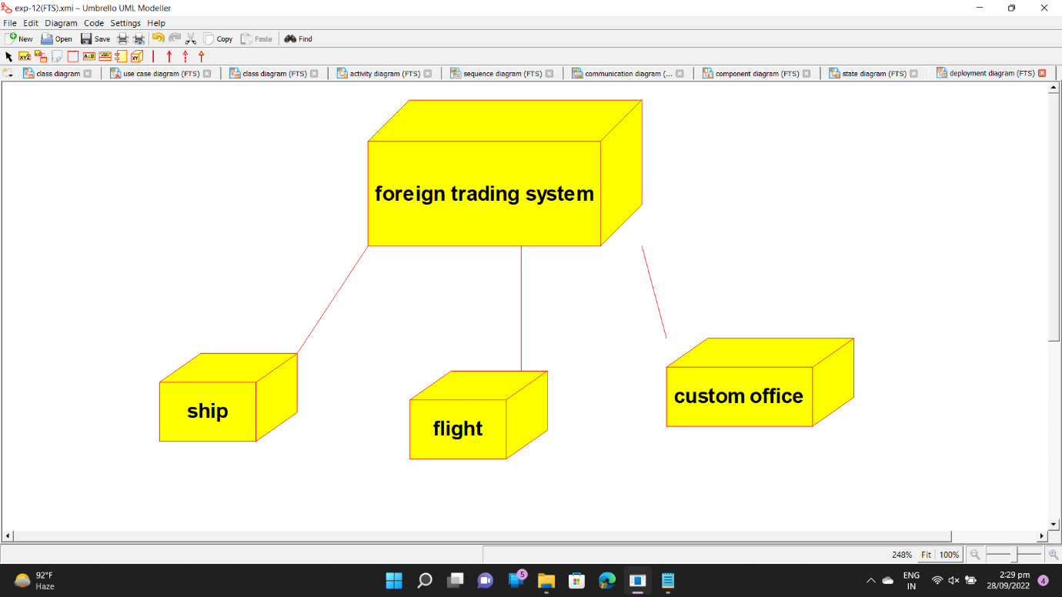

DEPLOYMENT DIAGRAM :-

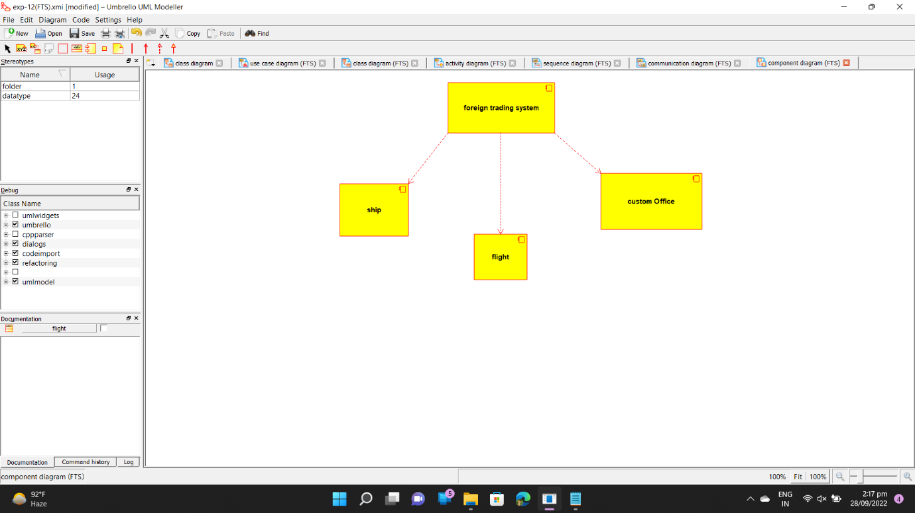

PROGRAM CODE :-

/**

* Class Customer

*/

public class Customer {

//

// Fields

//

public void quality;

private void order_product;

//

// Constructors

//

public Customer () { };

//

// Methods

//

//

// Accessor methods

//

/**

* Set the value of quality

* @param newVar the new value of quality

*/

public void setQuality (void newVar) {

quality = newVar;

}

/**

* Get the value of quality

* @return the value of quality

*/

public void getQuality () {

return quality;

}

/**

* Set the value of order_product

* @param newVar the new value of order_product

*/

private void setOrder_product (void newVar) {

order_product = newVar;

}

/**

* Get the value of order_product

* @return the value of order_product

*/

private void getOrder_product () {

return order_product;

}

//

// Other methods

//

/**

*/

public void payment()

{

}

/**

*/

public void deliver()

{

}

/**

*/

public void transport()

{

}

/**

* Class Supplier

*/

public class Supplier {

//

// Fields

//

public String product_supply;

//

// Constructors

//

public Supplier () { };

//

// Methods

//

//

// Accessor methods

//

/**

* Set the value of product_supply

* @param newVar the new value of product_supply

*/

public void setProduct_supply (String newVar) {

product_supply = newVar;

}

/**

* Get the value of product_supply

* @return the value of product_supply

*/

public String getProduct_supply () {

return product_supply;

}

//

// Other methods

//

/**

*/

public void available_product()

{

}

/**

*/

public void money_transaction()

{

}

}

/**

* Class Trading_Management_system

*/

public class Trading_Management_system {

//

// Fields

//

private String verify_product;

private int amount;

//

// Constructors

//

public Trading_Management_system () { };

//

// Methods

//

//

// Accessor methods

//

/**

* Set the value of verify_product

* @param newVar the new value of verify_product

*/

private void setVerify_product (String newVar) {

verify_product = newVar;

}

/**

* Get the value of verify_product

* @return the value of verify_product

*/

private String getVerify_product () {

return verify_product;

}

/**

* Set the value of amount

* @param newVar the new value of amount

*/

private void setAmount (int newVar) {

amount = newVar;

}

/**

* Get the value of amount

* @return the value of amount

*/

private int getAmount () {

return amount;

}

//

// Other methods

//

/**

*/

public void transport()

{

}

/**

*/

public void delivery_product()

{

}

/**

*/

public void money_transfer()

{

}

}